**Where2Film.eu**

**Business proposal**

**Jurgita Dumblyte x14110644**

**Olga Diomina x14108682**

**John Dizon x14723141**

**Mayowa Bakare x14503817**

Table of Content

**Business Idea & Target Market………………………………………………………………………..p 3**

**Competitors…………………………………………………………………………………………………….p 4**

**Expansion Plans for Year two……………………………………………………………..……………p 5**

**Further Expansion……………………………………………………………………………………………p 5**

**Marketing Strategy………………………………………………………………………………………….p 6**

**Software………………………………………………………………………………………………………….p 7**

**Security……………………………………………………………………………………………………………p 11**

**Additional IT Requirements……………………………………………………………………………..p 13**

**Hardware…………………………………………………………………………………………………………p 15**

**Networking……..……………………………………………………………………………………………….p 23**

**Additional Cost………..……………………………………………………………………………………….p 22**

**Summary……………………..………..…………………………………………………………………………p 26**

**Bibliography……………………………………………………………………………………………………..p 27**

**Work distribution in the team:**

* J.Dumblyte: Business Idea, Competitors, Expansion Plans, Marketing Strategy, Additional Costs.
* O. Diomina: Budget (Excel).
* J. Dizon: Business Idea, Software, Security, Additional IT requirements.
* M. Bakare: Hardware, Networks, Additional Costs

**Where2Film.eu is a database website specifically created for media professionals worldwide. Our mission is to help them to find new, picturesque and affordable filming locations thorough Europe, as well as local talent agencies and competent crew, equipment / vehicle rent, accommodation and catering companies capable to look after large groups of people and located in or close to the chosen area.**

**Business idea & Target Market**



Being in and around film industry for several years it could not be left unnoticed that while undoubtedly rewarding, work of film directors and producers is extremely grueling and stressful. After writing/editing scripts, solving funding issues and finding the right cast, there`s still a big mountain to climb, trying to find that one spectacular looking hill, castle or valley that is not yet seen in a number of films or TV shows; a location that is both cost-effective and picturesque, with reasonable insurance costs and preferably easy access. Our team decided to develop a website for all possible filmmakers` needs - targeted precisely to this market, with not just database of locations, but also including information of local film extras agencies, skilled stunt and stage combat masters, light/sound engineers and camera professionals, make-up, hair and costume artists. Furthermore, we want to add filming equipment and vehicle rent, hotels/hostels and eateries that could give comprehensive rates and would have capability to look after large groups of people.

To give a rough idea on what is happening in the film industry, we take Ireland as an example. While quite far from the glory of 2002, when there were over three hundred feature films, documentaries and TV series made in Ireland (this number does not include short films), Irish film industry seems to be picking up after recession (over 100 film productions made in 2012), with not just growing number of talented local studios productions, but also attracting companies from overseas (The Tudors, Vikings, Penny Dreadful, Camelot, Ripper Street – just to name a few). “Vikings” alone brought € 20 mln to Irish economy in 2012, with even bigger budgets, expanded number of episodes and employing over a thousand of local film extras in following years. Ireland is undoubtedly great for picturesque locations: some scenes from “Princess Bride” and “Harry Potter and the Half-Blood Prince” were filmed at the Cliffs of Moher, some parts of “Italian Job” and “The Tudors”-in Kilmainham Gaol, etc. Wicklow hills feature in so many local and overseas productions than can be easily recognized (same to tell about background artistes).

Considering that and also the fact that Ireland, while beautiful and beloved, is far from being the cheapest country in Europe, we decided not to limit our database with just local industry, but look further and include at least few other countries that undoubtedly have something magnificent to offer.

(Flynn and Tracy, 2013) (Cultural Heritage Ireland 2011) (IFTN, 2014)

**Competitors**



We are well aware that Where2film.eu not just has few direct competitors (take IFTN.ie as an example), but also plenty of potential somewhat relative competitors, which would include search engines such as Google, Yahoo, Bing and Yelp, as they are commonly used on the internet for different searches.

Even so, we dare to believe that we are better than our competitors because we are not just very focused on our target market and making our customer`s satisfaction our number one priority, as well as walking an extra mile assisting our clients with their bookings and negotiating for better deals and filming permits in various locations, but also because we do not limit ourselves with just Ireland`s database, as our competitors do. We dream big and work hard to be able to include South and East Europe regions by the year two.

**Expansion plans for the Year 2**



* Using our connections in media and motion picture industry we are confident and proud to present talent agencies, relative services companies, and a great number of urban, architectural, historical and landscape locations in Ireland, Northern Ireland, Slovakia, Czech Republic, Lithuania and Estonia. Our second year`s goal is to be able to include at least six more European countries. In order to achieve that, we will have to spend a lot of time traveling, gathering information, making new connections and expanding our collaborative network.
* Advertising our business at European Film Festivals, such as Kaunas International Film Festival (Lithuania), Venice Film Festival (Italy), San Sebastian International Film Festival (Spain), Cinematik (Slovakia), Berlin Fashion Film Festival (Germany), and many others.
* We hope to be able to make our website fully available in languages of every country that we have database on. In this we expect kind support from regional councils of countries that are included in our database, as they only benefit from increasing tourist flow and foreign expenditure.
* We shall also have to look into getting a new big external hard drive and a second bridge camera.

**Further plans**



Given our business makes profit in first two years, we have an ambition to make it a worldwide database.

**Marketing strategy**



We advertise our business on Google and Facebook; print leaflets and distribute them at various film festivals, such as Jameson international film festival, Darklight, Horrorthon, IFI and “Gaze” - Irish Gay and Lesbian film festival in Dublin, and few regional film festivals in Galway, Cork and Waterford.

Our source of income is mainly from firms and companies that wish to have their adverts (relative to the website`s content and purpose) placed on Where2Film.eu. We have few ideas how to make it more appealing:

* The website is user friendly and accessible free of charge.
* "Businesses discount offer": customers avail of offers through our website – booking, in example. Businesses such as local restaurants or hotels might want to offer discounts during not busy months or for a big groups, so we advertise that on our website and process that booking. When client purchases that deal through our website, we get 30% of the booking cost, what would be about 10% of our annual revenue.
* Competitive rates for advertising, no long term commitment, even better offer for the first three months.
* Website`s content is available in three languages: English, Russian and German at the moment. This is just one of the ways to show that we really care that our website`s visitors have just the best experience.

**Software**



**Software requirements:**

* GIMP
* Office 365 Home
* Windows Movie Maker
* Antivirus
* NoteTab Pro

**GIMP**

In our website we will be using GIMP as our photo editing software. This tool will allow us the ability to edit, format and enhance different photos that we want to appear in the business website, as photos and images are essential for the website.

GIMP is a free image editor. It is used for photo retouching and composition with many different capabilities. It also has many different software extension and plug-ins for any specific task and procedures. GIMP’s latest version can be downloaded for free as well as the extensions and plug-ins in their official website <http://www.gimp.org/>.

We have chosen GIMP as our main photo editing software because it is free of charge as well as its reputation as one of the free of charge software that can be able to contest or be an alternative to some of the top photo editing software because of its different extensions and plug-ins. This will also cut our cost.

(The GIMP Team, 2014)

2014 (GIMP)

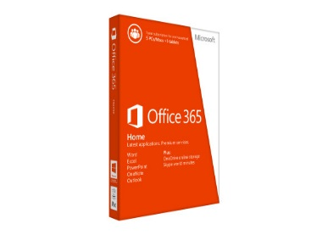**Office 365 Home**

We will be using Office 365 in our business as it is an essential tool to keep the efficiency of the business. Office 365 is a version of Microsoft Office that includes cloud access over the internet which allows us to store important data with OneDrive. This also includes the latest Microsoft Office applications such as Microsoft Word, Excel, PowerPoint, etc.

We have chosen the Office 365 because of its different features such as Microsoft Word to create documents necessary for the running a business as well as Microsoft Excel to help with financial management and also some few other features of the Microsoft Office. We have primarily chosen Office 365 Home because it is cost effective as we are going to use a set of computers and it can be easily upgraded as the business expands. We can install it on up to five devices.

|  |  |
| --- | --- |
| **System Requirements** | |
| Installed application: | Word, Excel, PowerPoint, OneNote, Outlook, Access, Publisher |
| Devices: | Microsoft Office on 5 PC’s or Mac, plus 5 iPads or Tablets. |
| Storage: | 1TB of storage on OneDrive. |
| Required Processor: | 1 gigahertz (Ghz) or faster x86- or x64-bit processor with SSE2 instruction set |
| Required Operating System: | Windows 8.1, Windows 8, Windows 7, Windows Server 2008 R2, Windows Server 2012, or Mac OS X 10.6 or later |
| Required Memory: | 1GB RAM (32 bit); 2GB RAM (64 bit) |
| Required Hard Disk Space: | 3.0GB available |
| **Cost: $99.99 (roughly €80.25) for 1-year subscription fee.** | |

(Microsoft, 2002)

2014 (Microsoft)

**Windows Movie Maker**

In our business we will be utilizing Windows Movie Maker as our video editing software. This tool will grant us the ability to create, edit and add audio to our videos as well as slideshows in our business. Windows Movie Maker also allows us to publish our video to different social media and cloud.

Windows Movie Maker is free as it is part of the Windows Essential. It can be downloaded for free in their website <http://windows.microsoft.com/en-ie/windows-live/movie-maker>.

We have chosen Windows Movie Maker because of it’s a free of charge software which is easy and straightforward to use. It can also publish video through different social media which can assist our marketing strategy.

(Microsoft Corporation, 2014)

2014 (Microsoft)

**Antivirus**

In our business we will require an Antivirus software in our computers to secure our computers from any malicious program or malware, as it can detect and prevent any malicious program or malware and remove the program. We will be using Norton Internet Security. More will be elaborated in the **(SECURITY SECTION)**.

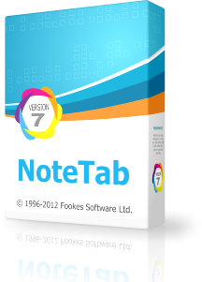**NoteTab Pro**

For constructing where2film.eu website we are going to use NoteTab Pro as we intend to start our website as a code base HTML so we will be needing a code base editor. We agreed to use NotePad Pro because it is an excellent replacement of Notepad for writing code that is fundamental for our website and it is a low cost efficient software.

NoteTab Pro is a text and HTML editor. NoteTab Pro will gives us the ability to develop our website from scratch so we can implement the things we would like to insert on our website. This also allows us to design our website using code generated syntax.

|  |  |
| --- | --- |
| **System Requirements** | |
| Operating System: | Windows 8, 7, Vista, XP, Me, NT4, 2008, 2003, 2000, 98 or Linux |
| RAM: | 64 MB of RAM |
| Disk Space: | 6 MB disk space |
| Microprocessor: | Pentium (or compatible) processor. |
| **Cost**  **$31.96 (roughly €25.70)** | |

(Fookes Holding Ltd., 2012)

2014 (NoteTab)

**Security**



**Security Requirements:**

* Norton Security
* Windows Azure

**Norton Internet Security**

It is essential to protect and secure any computer in the business world and so for our business we will be using Norton Internet Security to protect our computers from any malware or malicious program that can harm our computers.

Norton Internet Security is an antivirus software developed by Symantec Corporation that can protect, prevent and remove any malware and viruses in a computer. Norton Internet Security also covers different devices such as smartphones and tablets. They also offer wide range of security such as email spam filter which can detect any email which has identical data in a message and phishing protection which protects many important information such as passwords and credit card details from getting stolen.

We are using Norton Internet Security for our business because of its many features and guarantee. This will ensure that the data on our computers is safe and secure, especially the important data such as the usernames and passwords. It is also very affordable as it can be used by up to five devices such as smartphones and tablets.

|  |
| --- |
| **Operating System Supported** |
| * Microsoft® Windows® XP (32-bit) Home/Professional/Tablet PC/Media Centre (32-bit) with Service Pack 3 (SP 3) or later * Microsoft Windows Vista® (32-bit and 64-bit) Starter/Home Basic/Home Premium/Business/Ultimate with Service Pack 1 (SP 1) or later * Microsoft Windows 7 (32-bit and 64-bit) Starter/Home Basic/Home Premium/Business/Ultimate with Service Pack 1 (SP 1) or later * Microsoft Windows 8/8 Pro (32-bit and 64-bit) * Microsoft Windows 8.1/8.1 Pro (32-bit and 64-bit) * Current and previous two versions of Mac OS® X * Android™ 2.3 or later (must have the Google™ Play app installed) * iOS® 6 or later |
| **Cost**  **€47.99 – 1 year for 5 devices** |

(Symantec Corporation, 2014)

2014 (Norton)

**Windows Azure**

In our business we will need to back up our files and data for security and protection. We decided to use Microsoft Azure for cloud storage. Microsoft Azure will help us to back up the files and data that we need for the website as well as information that is necessary for our business.

Microsoft Azure is computing platform that allows the user to store data on the cloud. It manages and facilitates IT application that can be used to over the internet. Files and data can be uploaded and stored on the Microsoft server and can be backup if so need. It is pay as you use process which means that you only pay as you use Windows Azure.

We have chosen Windows Azure not only because it has cloud storage, but it also has different features that can be used to improve our website and make the business run efficiently. Windows Azure allows us to access our files and data on different platforms and is always accessible. The pay as you use feature will be useful as it reduces our costs.

The cost of using Windows Azure will vary depending on our use. We have predicted that we are going to use 1000GB of storage which will cost us €84.90 per month.

(Microsoft, 2013)

2013 (Microsoft)

**Additional IT requirements**



**Domain Name**

In our business we need a domain name for our website which is a certain name that can be identified over the internet. Domain name needs to be registered to be able to have the rights to use the name for the website.

We have chosen [www.register365.com](http://www.register365.com) to register our domain name where2film.eu. We have also registered the domain name wheretofilm.eu which we will link to where2film.eu using Meta Tag. We have decided to purchase both of them so that users who type WhereToFilm.eu in error shall still be directed to our website. We agreed to use [www.register365.com](http://www.register365.com) for the low cost of registering domain names. The cost of having to register two domain names is €2.49 each for first year.

(Namesco Ireland Limited, 2014)

**Web Hosting**

In our business website it is necessary to have a web hosting company which can host our website. Web hosting means that an organisation provides a service which allows a website to be viewed and accessed through the World Wide Web. The company also provides space for the website on their own servers.

We have chosen [www.register365.com](http://www.register365.com) to host our website as they have a diverse web hosting packages which we are able to take advantage of to improve our website. In this way we have different options for expansion of our website.

We have chosen [www.register365.com](http://www.register365.com) as our web host because of the criteria outlined.

Criteria:

|  |
| --- |
| **CRITERIA:** |
| * Unlimited storage space for our website to expand and upgrade in the upcoming year. * High percentage of hosting reliability which can give us an assurance that our website will be not go down so we will not lose a lot visitors. * High speed connectivity * High security firewall and intrusion detection system for protection which make our website secure and protected. * 7 days a week expert support. |
| **Cost:**  **€180.41 for the first 2 years** |

(Namesco Ireland Limited, 2014)

**Hardware**



**Hardware Requirements:**

* Computer Desktop - Dell [Inspiron 3847](http://www.dell.com/ie/p/inspiron-3847-desktop/pd?oc=cd84707&model_id=inspiron-3847-desktop)
* Wi-Fi Cable Modem Router - NETGEAR N450
* Printer - Dell Mono multifunction printer B1265dnf
* Headset- Jabra Pro 9450 Duo
* Bridge Camera - Sony DSC-HX300
* External Hard Drive - Dell External Hard Drive
* Landline: PANASONIC KX-TG6622EB Digital Cordless Phone

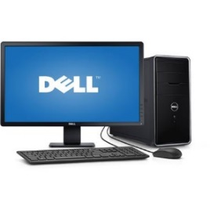**Computer Desktop – Dell** [**Inspiron 3847**](http://www.dell.com/ie/p/inspiron-3847-desktop/pd?oc=cd84707&model_id=inspiron-3847-desktop)

This desktop has been chosen because our company is an online database website and we needed a computer which is reliable enough to operate fast and efficiently. With the memory of 8 GB it should operate fast enough for our use and also the price was good as it was not too expensive for the quality it offers.

|  |  |
| --- | --- |
| **Technical Specifications:** | |
| *Processor* | - 4th Generation Intel® Core™ i5-4460 processor (6M Cache, up to 3.4 GHz). |
| *Operating system* | - Windows 8.1 64 bit ENG, SWE, DK, NOR, ESP. |
| *Memory* | -8GB Dual Channel DDR3 1600MHz (4GBx2). |
| *Hard drive* | -1TB 7200 rpm SATA 6Gb/s Hard Drive. |
| *Monitor* size | ( 24” ) |
| **Cost: €563.22** | |

(Walmart, 2014) 2014 (Dell)

**Wi-Fi Cable Modem Router** - NETGEAR N450

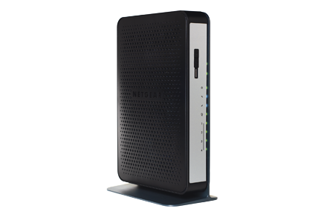**Overview:** Faster Internet. Better Wi-Fi. One Device

We decided to take advantage of the new, higher speeds cable providers are offering - without taking on their cable modem rental fees. This 2-in-1 Wi-Fi router and DOCSIS 3.0 cable modem unleashes 8x faster download speeds—up to 340 Mbps—faster, smoother Wi-Fi, and is compatible with all major cable Internet providers.

This router is needed to connect to the internet. It operates very fast, it is easy to use and it is affordable.

|  |  |
| --- | --- |
| **Technical Specifications:** | |
| *Speed* | DOCSIS 3.0 platform gives you fastest speed with magnificent range and performances along with HD streaming |
| *Sharing* | Insert USB hard drives and wirelessly access them. Beneficial for sharing your network quick and easy. |
| *Easy to use* | Connect cables together and click to connect to devices. Easy installs, Wi-Fi button to turn on and off, button to connect to Wi-Fi (push and connect). |
| *Security* | High security protection level from WPA/WPA 2. |
| **Cost: € 104.38** | |

(Dell, 2011)

2014 (Dell)

**Printer - Dell Mono multifunction printer B1265dnf** 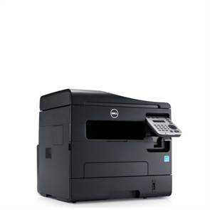

This printer is multifunctional which saves money from buying a separate scanner and a printer. It is also eco-friendly as we save pages with double sided printing function installed. We can also print from our phones as it connects to our devices.

Sets of cartridges for printer are available for € 169.63 (4 cartridges)

|  |
| --- |
| Features |
| * 4 in 1 printer, scanner, copy and fax. * No ink toner needed. * Double sided printing, very high quality printed pages, network connections. * High speeded printing with trust worthy performances every time. * You can also connect to mobile devices and print form your device. * You can print from your android and IOS devices from dell print and google cloud print. |
| **Cost: €256** |

(Dell Inc., 2014)

2014 (Dell)

**Headset - Jabra Pro 9450 Duo**

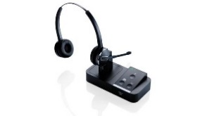**Overview:** This wireless headset is very beneficial for a multitasking telephony environment. Very suitable for office use as they can answer phones directly from headset or on the computer.

We chose it as it is suitable for office use as we will be spending time talking and using the computer at the same time so the device is perfect for that purpose. It is certified by Microsoft and Cisco which means it is a high standard device to use.

|  |  |
| --- | --- |
| **Features:** | |
| Connectivity | Talk range is up to 135metres/450ft. Supports Microsoft windows, conference Call capacity is 4 and works with traditional desk phones. |
| Microphones | Clear hearing, removal of noise from background, adjustable volume and also choice to mute. |
| Battery and Power | 10 hours of talk time, 38 hours of battery life and it takes 2 hours to full charge. |
| Certifications | Certified by Cisco, Avaya and Microsoft |
| **Cost: € 283.26** | |

(GN Netcom A/S, 2014)

2014 (Jabra)

**Bridge Camera - Sony DSC-HX300**

This camera 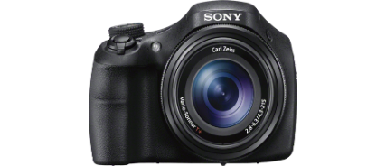 enables us to get high quality professional pictures and videos of scenic regions, hotels, restaurants, locations and anything we need to take picture of to display in our website. High resolution images and videos would give our searchers a quality idea of what exactly they are looking for. This bridge camera is significantly cheaper than bridge cameras of Sony competitors, such as Nikon or Canon, but the standards are still very high and absolutely satisfying our needs.

|  |
| --- |
| Features: |
| * High quality shooting, DLSR –style shooting sits steadily in hand. * 20.4 mega pixel with even areas of dim and low light. * High quality lens with powerful 50x optical zoom. * Wide angle lenses. * Optical steady shots, no blur and smooth pictures taken. * Control your light and exposure manually with P/S/A/M manual. * Intelligent focus gets wide range of scenes and adjusts itself automatically so you will get close perfects shots every time. * Blur free shots even with moving actions with superior auto. * Powerful clear close up image zoom. * Extra wide panorama capture. * Clear vivid colour capture richness. * Picture effect for videos, panorama and movies. |
| **Cost: € 349.99** |

(Sony Europe Ltd., 2014)

2014 (Sony)

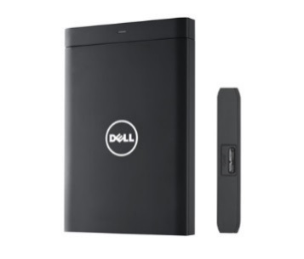**Dell External Hard Drive**

The external hard drive with the 1TB storage is essential for our business to store large amount of photo images, videos and data. It keeps computer performance level high. It’s easy to use and light in weight which makes it easy to carry if needed to. Preliminary price is € 72.08.

|  |
| --- |
| Features: |
| * Smooth and simplistic look, easy to store and share all your pictures and videos. * Has fast USB 3.0 connectivity which is nearly up to 10 times faster than normal 2.0 USB allows you to share and transfer large amount of pictures videos or music simply just drag and drop. * 1TB storage enables you to up to 250,000 songs 300,000 pictures and 120 DVD movies in the device. With large amount of space in external hard drive it will most certainly increase computers performance. |
| **Cost: €72.08** |

(Dell, 2012)

2012 (Dell)

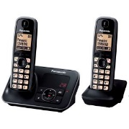**Landline: PANASONIC KX-TG6622EB Digital Cordless Phone**

This telephone is needed for our business purposes as we will need it to talk and communicate with our future potential customers .It comes with 2 handsets so we can put in two different parts of the office so customers won’t spend long calling before getting an answer. As we are likely to be looking up information on the desktop at the same time as being on the phone it is also very handy to have come with speaker phone and a shoulder grip enabling us to carry out 2 jobs at once. It is also quite affordable for us to purchase it.

|  |
| --- |
| Features: |
| * This is a cordless phone with answering machine. * Useful for both home and office use. * It comes with 2 handsets so you don’t have to rush to get the phone anymore. * Comes with speakerphone so you don’t have to place the phone onto your ears while talking to the phone. * It also comes with a shoulder grip so you can leave the phone on your shoulder while you do other things at the same time as being on the phone (perhaps typing on the computer/laptop etc.) * Impressive 170 hours of battery life with 15 hours of call time. * The answering machine can hold at least 18 minutes of messages left for you on the phone (essential for business purposes). |
| **Cost: €62.99** |

(DSG Retail Ireland Ltd, 2014)

2014 (PC World)

**Networking**



**Networking Requirements:**

* Landline - Eircom bundle phone and broadband NETWORK

**Landline: Eircom bundle phone and broadband**

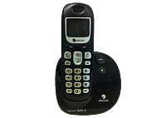

|  |  |
| --- | --- |
| **Broadband** | **Phones** |
| * Up to 100Mb download speed * Unlimited download usage * Free wireless modem * Free connection * 18 month contract | * Off-Peak local and national calls   (Monday – Friday 7am-7pm)  (Saturday - Sunday all day)   * 30 minutes of free calls to all mobile networks |
| **Cost: € 38 per month for the first 6 months** | |

The main telecommunications services provider in Ireland, Eircom is well known for their dedication to customers, high quality of service, quick and efficient dealing with complaints. As new customers we will avail of great value special Bundle Deal offer €38 per month for the first 6 months. After those 6 months the cost is going to be €48 euro per month, which is still very cost efficient.

(Eircom, 2014)

2014 (Eircom)

**Additional costs**



**Additional costs consist of:**

* Office rent. As we do not require a spacious reception and conference rooms, we picked a simple office that is absolutely enough for our needs, with the price per month €500, which would make €6000 per annum.
* Office insurance. We have been considering Chill insurance company as they are known for low prices, but at the end of the day we chose widely trusted FBD insurance company. After an appointment with their insurance specialist we were advised an insurance quote €7500 per year; standard business insurance package that would include accidental property damage cover, hardware insurance, employer`s liability (due to specifications of our business we do not require public or product liability), business interruption (such as fire, flood, natural disasters); with the addition of Professional Indemnity insurance. Although it might look like a luxury we can barely afford – especially on the first year, we decided to get a cover for all odd claims, like loss of documents, giving a thoughtless and irresponsible advice, and other misunderstandings.

(FBD Insurance plc., 2008)

* Utilities. Where2film.ie is just a small company with a modest size office, so our utility bills will not exceed €50 per month, what will make quite a humble amount of €600 per year.
* PC maintenance. Preliminary continuous cost of computer maintenance is €360 per annum, or € 30 per month.
* Video conferencing: Cisco WebEx.

**Video conferencing: Cisco WebEx.**

This is a cloud based server to arrange small meetings with customers, mangers and everyone you practically need to communicate with. For our business, meetings can be important with company managers to negotiate prices of advertising fees.

|  |
| --- |
| Features: |
| * Up to 7 people can be added into a video conference. * It is easy to use. * WebEx can be downloaded to phone devices on WebEx apps. * While in the meeting you can also share documents on your computer so that the people that your conferencing with can see it as well. * Sharp HD video quality. * Also has audio calls. * 100 attendees. * Up to 7 people per video conference. * Phone calls INS. * Enable the option to record voice and video meetings. * Free app download onto your phones and devices. |
| **Cost: €80 per month** |

(Cisco, 2012)

**Summary**



In our business idea of a website we have gathered up the necessary information in order for the business to start. We have compiled all the components needed as well as the cost for each required section and summarized the breakdown of the money and funds needed for our business

With the information from our Budget Spreadsheet have projected we are looking for the amount of €13,000 worth of investments to start our business. Most of the investment money will be concentrated on Hardware and Additional Cost, as this is the major part of starting our business as a website. The investments and funds will be primarily employed in the first month of the business where we will be purchasing the materials needed and setting up the office premises.

**Bibliography:**



Cisco, (2012) ‘Cisco WebEx’. [Online]. *Cisco WebEx.* Available from: <http://www.webex.co.uk/> [Accessed 15 November 2014]

Cultural Heritage Ireland (2011) ‘Films made in Ireland’. [Online]. *Cultural Heritage Ireland*. Available from: <http://www.culturalheritageireland.ie/index.php/irish-history-from-the-annals/48-films-made-in-ireland> [14 November 2014].

Dell (2011) ‘NETGEAR N450 - Wireless router - cable mdm - GigE - 802.11b/g/n - 2.4 GHz : Networking - Adapters, Cables, Wireless Routers | Dell’. [Online]. *Dell*. Available from: <http://accessories.us.dell.com/sna/productdetail.aspx?c=us&l=en&s=dhs&cs=19&sku=A7839356> [Accessed 13 November 2014].

Dell (2012) ‘Dell External Hard Drive - 1 TB: Storage: Hard Drives & Storage Media | Dell’. [Online]. *Dell* Available from: <http://accessories.us.dell.com/sna/productdetail.aspx?c=us&l=en&cs=19&sku=342-5537> [Accessed 13 Nov. 2014].

Dell Inc. (2014) ‘Dell Mono Multifunction Printer - B1265dnf | Dell Ireland’. [Online]. Available from: <http://www1.euro.dell.com/content/products/productdetails.aspx/dell-b1265dnf-printer?c=ie&l=en&s=dhs&cs=iedhs1&baynote_bnrank=0&baynote_irrank=1&~ck=dellSearch>[Accessed 13 November 2014].

DSG Retail Ireland Ltd (2014) ‘PANASONIC KX-TG6622EB Digital Cordless Phone with Answering Machine - Twin Pack’. [Online]. *PC World*. Available from: <http://www.pcworld.ie/Product/panasonic-kxtg6622eb-digital-cordless-phone-with-answering-machine-twin-pack/306383/387.1.2> [Accessed 15 November 2014]

FBD insurance plc. (2008) ‘Office Based Professional Insurance’. [Online]. *FBD.* Available from: <http://www.fbd.ie/business-insurance/office-insurance/> [Accessed 15 November 2014]

Flynn, R. and Tracy, T. (2013) “Irish film and TV review: Introduction”. *Estudios Irlandeses* (8): pp. 196-199.

Fookes Holding Ltd. (2012) ‘Buy Now’ [ONLINE] *NoteTab* Available from: <http://www.notetab.com/buy-now.php> [Accessed 14 November 2014].

GN Netcom A/S (2012) ‘Wireless Headset, Jabra PRO™ 9450’. [Online]. *Jabra*. Available from: <http://www.jabra.com/products/wireless_headsets/jabra_pro__9400_series/jabra_pro_9450> [Accessed 13 November 2014].

IFTN (2014) ‘IFNT’ [Online]. *IFNT*. Available from: [www.iftn.ie](http://www.iftn.ie) [Accessed 15 November 2014]

IrishCentral LCC (2014) ‘Movies you never knew were filmed in Ireland (VIDEOS)’. [Online]. *Irish Central*. Available from: <http://www.irishcentral.com/culture/entertainment/top-10-most-surprising-movies-filmed-in-ireland-see-photos-128199433-237790501.html> [14 November 2014].

Landline / Eircom (2014) ‘eFibre Advance Unlimited’. [Online]. *Eircom*. Available from: <https://www.eircom.net/broadband/productDetails?id=1> [Accessed 13 Nov. 2014].

Microsoft (2013) ‘Azure: Microsoft’s Cloud Platform’ [Online]. *Microsoft Azure.* Available from: <http://azure.microsoft.com/en-us/> [14 November 2014].

Microsoft (2014) ‘Buy Microsoft Office 365 Home – Microsoft Store’ [Online]. *Microsoft Store.* Available from: <http://www.microsoftstore.com/store/msusa/en_US/pdp/Office-365-Home/productID.286395000> [Accessed 14 November 2014].

Microsoft (2014) ‘Movie Maker - Microsoft Windows’[ONLINE] *Windows.* Available from: <http://windows.microsoft.com/en-ie/windows-live/movie-maker>. [Accessed 14 November 2014].

Namesco Ireland Limited (2014) ‘Best hosting solution – Web hosting packages comparison – website host’ [ONLINE] Register365 Available from: <http://www.register365.com/web-hosting/packages/compare> [Accessed 14 November 2014].

Namesco Ireland Limited (2014) ‘Domain name search - Irish domain registry - Domain name registration’ [ONLINE] Register365 Available from: <http://www.register365.com/domain-names>. [Accessed 14 November 2014].

Sony Europe Ltd. (2014) ‘Sony HX300 Camera with 50x Optical Zoom’. [Online]. *Sony*. Available at: <http://www.sony.ie/electronics/cyber-shot-compact-cameras/dsc-hx300#pdp_slideshow_default> [Accessed 13 Nov. 2014].

Symantec Corporation (2014) ‘Norton Security – Antivirus Software | Norton’ [Online]. *Norton.* Available from: <http://ie.norton.com/norton-security-antivirus> [Accessed 14 November 2014].

The GIMP Team (2014) ‘GIMP - The GNU Image Manipulation Program Available’ [ONLINE] *GIMP.* Available from: <http://www.gimp.org/>. [Accessed 14 November 2014].

Walmart Stores, Inc. (2014) ‘Dell Inspiron 3847 Desktop PC with Intel Core i5-4460 Processor, 8GB Memory, 24" Monitor, 1TB Hard Drive and Windows 8.1 - Walmart.com’. [Online]. *Walmart*. Available from: <http://www.walmart.com/ip/Dell-Inspiron-3847-Desktop-PC-with-Intel-Core-i5-4460-Processor-8GB-Memory-24-Monitor-1TB-Hard-Drive-and-Windows-8.1/36976911> [Accessed 7 November 2014].

**Bibliography Images**



Dell, (2014). [Image] Available at: <http://i.dell.com/resize.aspx/printer-b1265dnf-right-500/295>

[Accessed 14 Nov. 2014].

Dell, (2014). [Image] Available at: <http://snpi.dell.com/snp/images/products/mlrg/en-us~A7839356/8b435ac9-d2da-498e-beb0-50d124a7649c.jpg>

[Accessed 14 Nov. 2014].

Dell, (2014). [Image] Available at: <http://snpi.dell.com/snp/images/products/mlrg/en-us~342-5537/342-5537.jpg>

[Accessed 14 Nov. 2014].

Eircom, (2014). [Image] Available at: <https://www.eircom.net/opencms/export/sites/default/.galleries/eircom/laptop-efibre.png>

[Accessed 14 Nov. 2014].

Eircom, (2014). [Image] Available at: <https://www.eircom.net/opencms/export/sites/default/.galleries/eircom/phone-large.png>

[Accessed 14 Nov. 2014].

Jabra, (2014). [Image] Available at: <http://www.jabra.com/~/media/PIM/Product%20Images/Jabra%20PRO%209400/Jabra_PRO_9450_01_1440X810.jpg?bc=White&h=384&w=684>

[Accessed 14 Nov. 2014].

PC world, (2014). [Image] Available at: <http://www.pcworld.ie/Images/PCWorld/productimages//Large/252923.jpg>

[Accessed 14 Nov. 2014].

Sony, (2014). [Image] Available at: <http://sonyglobal.scene7.com/is/image/gwtprod/0ce5766acb8ef23853a987718d966cfc?fmt=png-alpha&wid=1014&hei=396>

[Accessed 14 Nov. 2014].

Walmart, (2014). [Image] Available at: <http://i5.walmartimages.com/dfw/dce07b8c-a468/k2-_585831a9-055d-42dc-ac8e-6bd63bf3b030.v1.jpg>

[Accessed 14 Nov. 2014].

**Appendices**



**E-mail Snapshot**

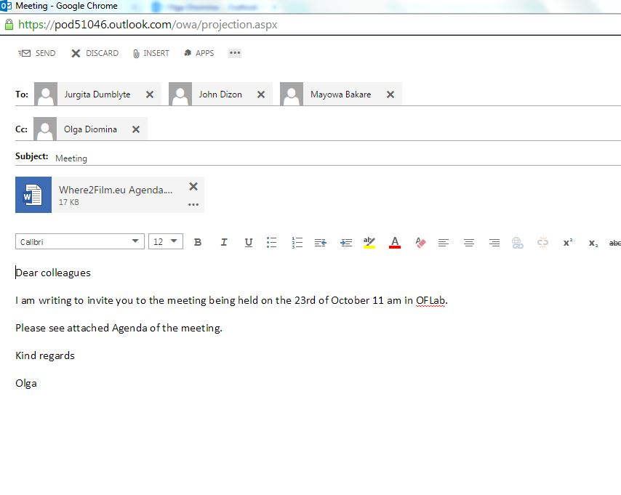

**Where2Film.eu**

**Agenda**

Date of Meeting: Thursday 23rd October 2014

OFLab 3.04 – 11.00am

Present: John Dizon 14723141

Mayowa Bakare 14503817

Jurgita Dumblyte 14110644

Olga Diomina 14108682

Apologies:

**Agenda**

1. Minutes
2. Discuss what hardware and software are going to be used.
3. Talk about security issues of the website.
4. Networks requirements.
5. Marketing ideas.
6. Expansion plans.
7. Outline costs of the company.
8. Any other business

**Where2Film.eu**

**Meeting Minutes**

**Thursday 23rd of October 2014**

**OFLab – 11am.**

Present: John Dizon 14723141

Mayowa Bakare 14503817

Jurgita Dumblyte 14110644

Apologies:

Minute taker: Olga Diomina 14108682

|  |
| --- |
| **Discussion** |
| **Minutes:**  The Minutes of the previous meeting held on the 21st October 2014 circulated & agreed:   * John proposed that our website should have reviews and recommendations from website’s users regarding locations and businesses in the surrounding area. This was decided to be considered for the future expansion. * Jurgita volunteered to do the Irish film industry research. * Group members contribution in the Business Proposal as follows:   J. Dumblyte: Business Idea, Target Market, Competitors, Expansion Plans, Marketing Strategy, Additional Costs.  O. Diomina: Expansion Plans, Marketing Strategy, Budget (Excel), Appendixes.  J. Dizon: Business Idea, Software, Security, Additional IT requirements.  M. Bakare: Hardware, Networks, Additional costs.  **Minutes of Meeting:**   * Mayo has done the research about Hardware that is needed for the Where2Film.eu business. He found good value Dell Desktops with 8GB RAM as was suggested by Olga, so the website would work fast and efficiently.   Also he found good value landline phones, headsets, external hard drive, bridge camera and printer.   * John looked into Software requirements and found with the following affordable software we are going to use:   GIMP, Office 365 Home, Windows Movie Maker, NoteTab Pro.   * John also proposed to use Norton Security Antivirus and Windows Azure cloud storage. * For our Networks requirements Mayo found a good deal from Eircom landline bundle and broadband. * Marketing ideas:   Jurgita proposed to advertise our business on Google and Facebook, as well as print out flyers and distribute them at the film festivals.  Olga suggested to use “Business discount offer” as other income. It lets users to book hotels or restaurants advertised on our website during discount offer times through our website.  Also Jurgita suggested to make it a multilingual website.   * As for Expansion Jurgita proposed to travel in order to do a research for filming picturesque locations. Suggested to use our filming industry connections as our strong initial point, which in second year would be expanded to our own location screening through traveling.   Olga said, that in few years depending on our revenue the business should go worldwide.   * Set-up costs will consist of software, hardware, networks, rent of premises and advertisement. Approximately €13000 will be required for our business to launch. * Any other Business   **Next meeting to be held 30th of November to view the progress of the Business Proposal. Time to be confirmed.** |